**Virginia Motorsports Technology Committee**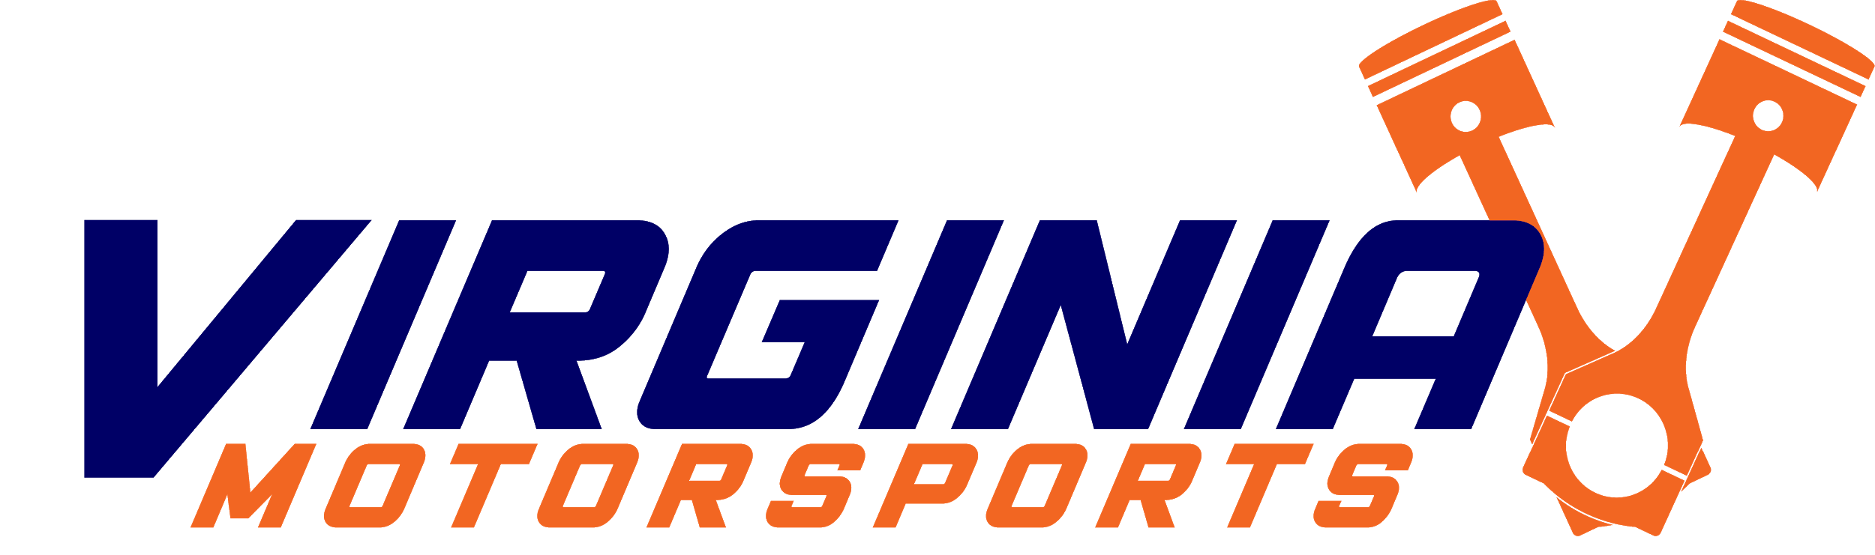

Meeting Agenda & Minutes

*Date and Time*: 10/25/2020 @ 4 PM

*Next meeting*: 11/1/2020 @ 4 PM

**Agenda**

1. Discussion & Other Topics
   1. Updates on projects
      1. Vishal - Still working on Inventory stuff
      2. Daniel - Still working on Digital Signing stuff
      3. Will - Still working on Wiki
      4. Henry - Talk to Mason about SAE sensor electronic stuff
   2. Next Meeting
      1. Zoom meeting Nov. 1st @ 4PM